

UTHAI-Humanoid

**Kinematics Properties**

Version [0.0.4]

Modified: 2018/3/12

Principle authors:

Liews

TAA

BIRD

## UTHAI Humanoid

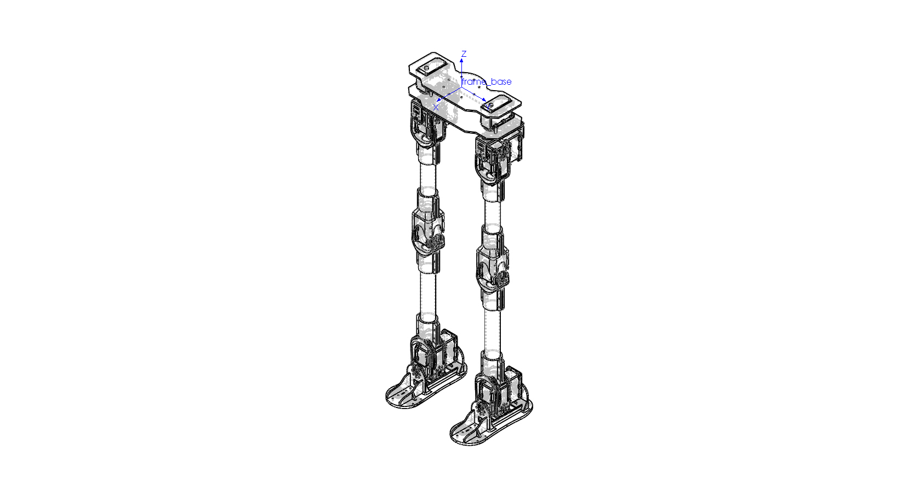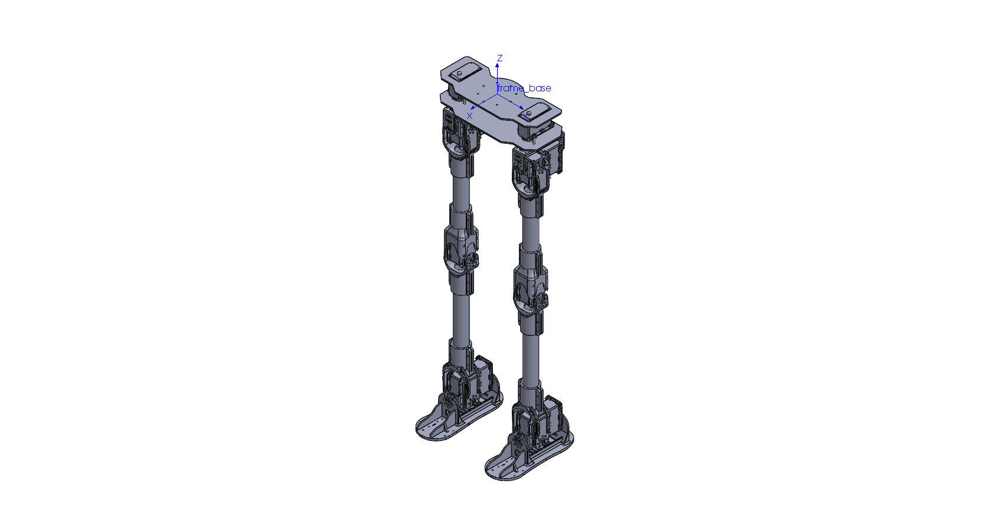

## UTHAI frames

## UTHAI Kinematics LEG

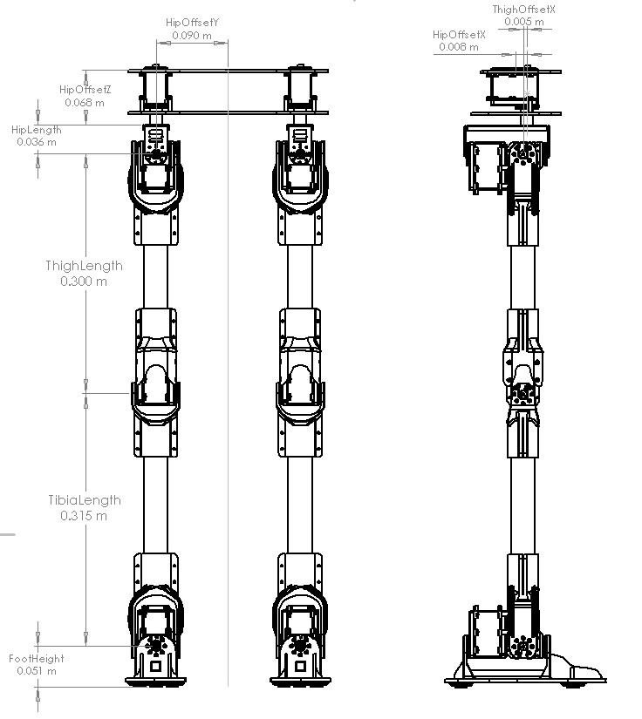

| Name | Size [m] |
| --- | --- |
| HipOffsetX | 0.008 |
| HipOffsetY | 0.090 |
| HipOffsetZ | 0.068 |
| HipLength | 0.036 |
| ThighOffsetX | 0.005 |
| ThighLength | 0.300 |
| TibiaLength | 0.315 |
| FootHeight | 0.051 |

## UTHAI Joint limited

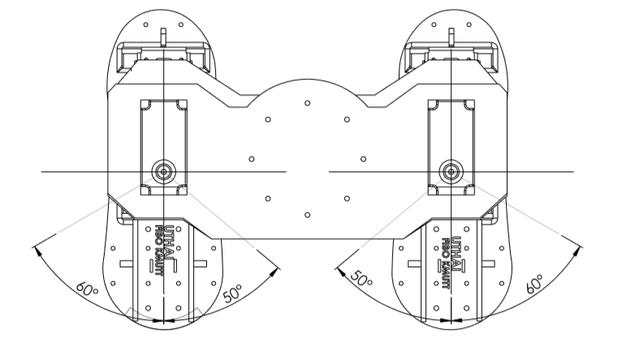

| Joint Name | Range in Degrees | Range in Radians |
| --- | --- | --- |
| r_hip_yaw_joint | -60.0 to 50.0 | -1.047197 to 0.872664 |
| r_hip_roll_joint | -40.0 to 50.0 | -0.698131 to 0.872664 |
| r_hip_pitch_joint | -120.0 to 40.0 | -2.094395 to 0.698131 |
| r_knee_pitch_joint | 0.0 to 130.0 | 0 to 2.268928 |
| r_ankle_pitch_joint | -30.0 to 60.0 | -0.523598 to 1.047197 |
| r_ankle_roll_joint | -20.0 to 60.0 | -0.349065 to 1.047197 |
| l_hip_yaw_joint | -50.0 to 60.0 | -0.872664 to 1.047197 |
| l_hip_roll_joint | -50.0 to 40.0 | -0.872664 to 0.698131 |
| l_hip_pitch_joint | -120.0 to 40.0 | -2.094395 to 0.698131 |
| l_knee_pitch_joint | 0.0 to 130.0 | 0 to 2.268928 |
| l_ankle_pitch_joint | -30.0 to 60.0 | -0.523598 to 1.047197 |
| l_ankle_roll_joint | -60.0 to 20.0 | -1.047197 to 0.349065 |

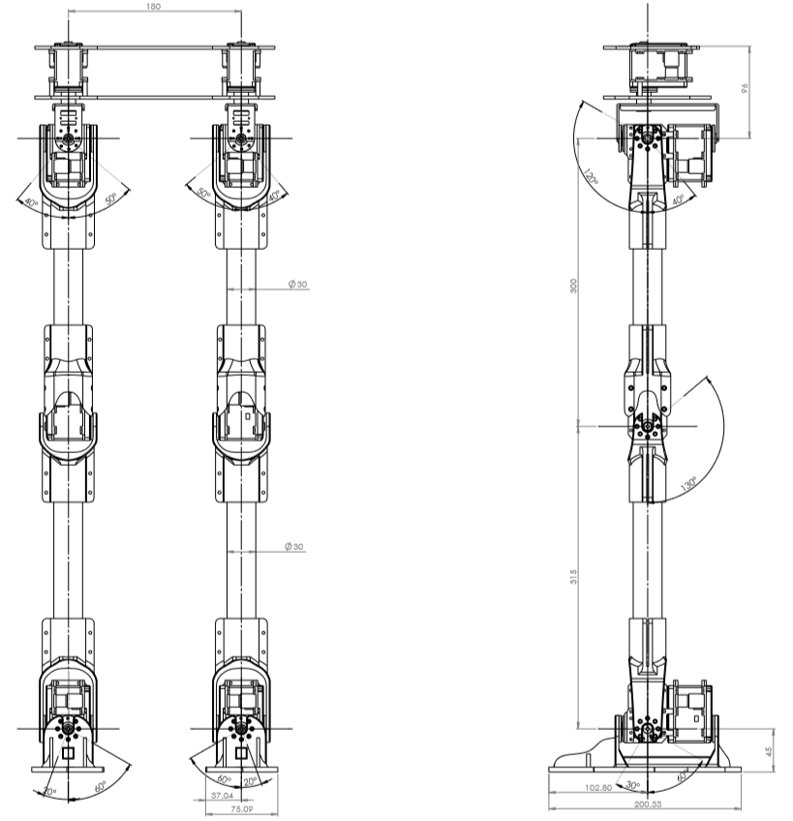

## UTHAI URDF

| Parent | Child | Translation [m] | | | Rotation [radian] | | |
| --- | --- | --- | --- | --- | --- | --- | --- |
| X | Y | Z | Roll | Pitch | Yaw |
| base | pelvis_link | 0 | 0 | 0 | 0 | 0 | 0 |
| pelvis_link | r_hip_yaw_link | 0.008 | -0.09 | -0.06 | 0 | 0 | -1.5708 |
| r_hip_yaw_link | r_hip_roll_link | 0 | 0 | -0.036 | 1.5708 | 0 | 0 |
| r_hip_roll_link | r_hip_pitch_link | 0 | 0 | -0.005 | -1.5708 | 0 | -1.5708 |
| r_hip_pitch_link | r_knee_pitch_link | 0.3 | 0 | 0 | 0 | 0 | 0 |
| r_knee_pitch_link | r_ankle_pitch_link | 0.315 | 0 | 0 | 0 | 0 | 0 |
| r_ankle_pitch_link | r_ankle_roll_link | 0 | 0 | 0 | 1.5708 | 0 | 0 |
| r_ankle_roll_link | r_foot_ft_link | 0.05 | 0 | 0 | 0 | -1.5708 | 0 |
| pelvis_link | l_hip_yaw_link | 0.008 | 0.09 | -0.06 | 0 | 0 | 1.5708 |
| l_hip_yaw_link | l_hip_roll_link | 0 | 0 | -0.036 | 1.5708 | 0 | 0 |
| l_hip_roll_link | l_hip_pitch_link | 0 | 0 | -0.005 | -1.5708 | 0 | -1.5708 |
| l_hip_pitch_link | l_knee_pitch_link | 0.3 | 0 | 0 | 0 | 0 | 0 |
| l_knee_pitch_link | l_ankle_pitch_link | 0.315 | 0 | 0 | 0 | 0 | 0 |
| l_ankle_pitch_link | l_ankle_roll_link | 0 | 0 | 0 | 1.5708 | 0 | 0 |
| l_ankle_roll_link | L_foot_ft_link | 0.05 | 0 | 0 | 0 | -1.5708 | 0 |

## UTHAI DH Tables

## 